MONDAY 29TH  PUBLIC HOLIDAY  CLOSED | TUESDAY 30TH  Synergy Park  KINGS PARK  Arrive: 10.30am  Depart: 2.00pm | WEDNESDAY 1ST  Science Day  We have lots of  Experiments planned. Get ready to be scientists!  Home day | THURSDAY 2ND  Football stadium tour  Paterson’s Stadium  Arrive: 10.00am  Depart: 2.00pm | FRIDAY 3RD  ^{PERTH ZOO}  Arrive: 10.00am  Depart: 2.00pm
MONDAY 6TH  Sport’s Day  Tom Bateman  Oval.  Arrive: 10.30am  Depart: 2.00pm | TUESDAY 7TH  REmida  Art Workshop  Perth City  Arrive: 10.00am  Depart 1.00pm | WEDNESDAY 8TH  Dress up day  Come dressed in your favourite costume. We will have lots of fun games and activities to do!  Home day | THURSDAY 9TH  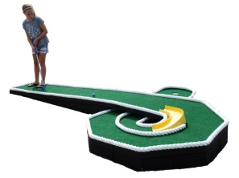  Mini Golf  Swan Valley  Arrive: 10.00am  Depart: 2.00pm | FRIDAY 10TH  JUNGLE GYM  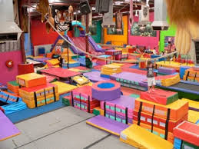  Arrive: 10.00am  Depart: 2.00m
OCTOBER SCHOOL HOLIDAY PROGRAM
29TH September- 10th October 2014

