SKOOLEEZ APRIL SCHOOL HOLIDAYS 2015

Monday 6th | Tuesday 7th | Wednesday 8th | Thursday 9th | Friday 10th
CLOSED | BBQ lunch at Heathcoat pirate park. Team games on the sand  *Hat, drink bottle and sun smart clothing  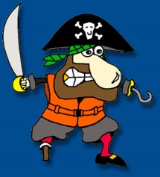 | Full of Fun indoor centre Malaga  *Hat, drink bottle and socks  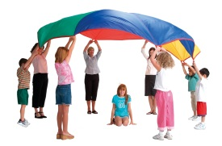 | Roller-skating Morley. This is one of the Skooleez children favourite excursions.  *socks  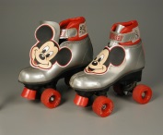 | Back by popular demand! Treasure hunt, the location will be Kings Park.  *Hat, drink bottle and sun smart clothing 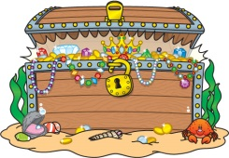

Monday 13th | Tuesday 14th | Wednesday 15th | Thursday 16th | Friday 17th
In house!  Wear your messy clothes and get your gardening gloves on!  *Hat and drink bottle | Aviation heritage museum Bull Creek  *Hat and drink bottle | Whiteman Park for steam train ride for pirate show.  Bring your bathers! If the sun is still shining we will have play in the water spouts.  *Bathers and towel, change of clothes, hat and drink bottle | Penguin Island tour. We will be getting on a ferry to penguin island and visiting the discovery centre  *Bathers and towel, change of clothes, hat and drink bottle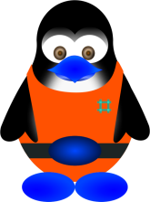 | Requested by many!  Volcano Park Belmont  *Hat, drink bottle and sunsmart clothing  