Monday | Tuesday | Wednesday | Thursday | Friday
28th September 2015 | 29th September 2015 | 30th September 2015 | 1st October 2015 | 2nd October 2015
PUBLIC HOLIDAY  Sorry we are closed | Cicerello’s lunch tour  Observe the fish tanks, experince the touch pool and then enjoy a beach combing tour  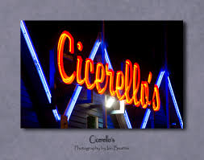 | Mandurah Dolphin Tour  Cruise along the canals in our own private boar while we watch for Dolphins playing in the water.  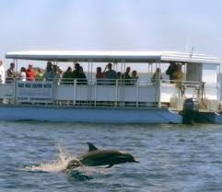 | Valley Rally exploration  The children will be the guides and will instruct the Educators to go by following the clues! What will we find along the way? | Caversham Wildlife park  Meet the friendly wombats up an personal and watch a farm show.  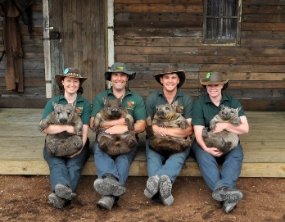
5th October 2015 | 6th October 2015 | 7th October 2015 | 8th October 2015 | 9th October 2015
Home day  Join us in making real super hero costumes. Everyone gets to take home their own creative super hero cape and mask! | Piney lakes sensory park  This park has lots of hidden treasures designed for children play and imagination  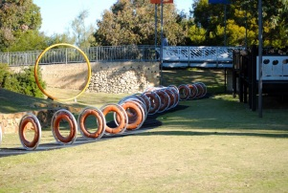 | The Beach House  Brand new indoor play centre! It has many different play rooms  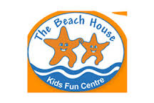 | Joseph Ashton Circus  Come run away with the circus and enjoy a fun filled day with clowns and swining trapeze  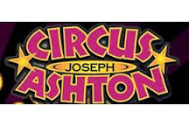 | Lunch in Woodridge park  BBQ lunch with lots of exporling and fun to be had!  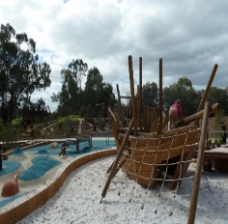
Dear Families,
Please select your days by ticking the boxes next to your required dates. Please note, all absent days will still be charged unless one weeks notice is given in writing. Please advise the centre if your child won’t be attending a booked excursion, it is essential we leave on time to meet our booking times. We will be leaving 9.30am every morning, please ensure your child has hat, water bottle and appropriate clothing for outdoor play. Thank you for your understanding.
Kind Regards,
Skooleez Forrestfield Management.
Child’s Name: _______________________ Parent name___________________ Signature: __________________________ Date: _________________

